

**Roadside Assistance (RSA)**

**Product Requirements Document (PRD)**

***V1.2***

**Document Status:** Draft

**Document Type:** Product Requirements Document (PRD)

**Classification:** Confidential

**Department:** CVPP

**Author:** Serena Sun

|  |  |
| --- | --- |
| Reviewing Manager: |  |
| Document Location: |  |
| Date Released: | <Date the reviewing manager approved this document MM/DD> |

**Project:** DuerOS IVI

Contents

1 General Assumptions 3

1.1 User 3

1.2 Vehicle 3

2 Requirement 3

2.1 Description 3

2.2 Assumptions 3

2.3 User Stories 3

2.4 Requirements 3

2.5 Use Cases 3

3 Classification Key 5

4 Document Status Key 5

5 Terms, Acronyms and Definitions 5

6 Changes 6

7 Contacts 6

# General Assumptions

## User

The user is assumed to be responsible for:

* Preparing a smart phone and link phone with the car via bluetooth

## Vehicle

For a vehicle to support the DuerOS related feature, the vehicle must have all of the following:

* With DuerOS support integrated in vehicle infotainment system
* Ignition is on and IVI is launched
* Linked with phone via bluetooth

# Requirement

## Description

If the car have breakdown, DuerOS vehicle owner can contact Ford Roadside Assistance (RSA) for help.

## Assumptions

Ignition is on and IVI is launched. Phone linked with Car via Bluetooth

## HMI Mockup

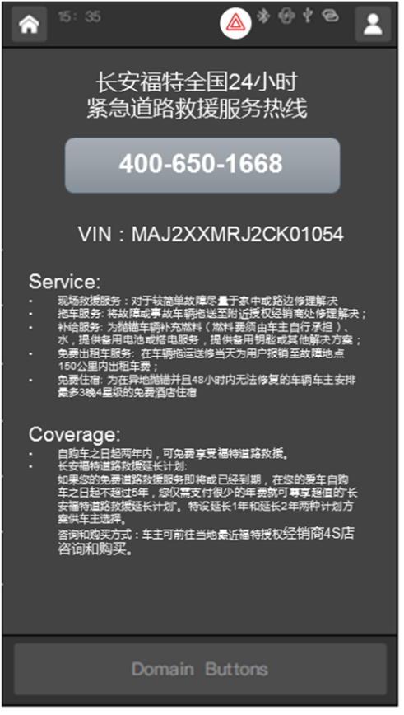

RSA entrance on HMI: follow HMI design guidence

## User Stories

|  |  |
| --- | --- |
| **User Story ID** | **User Story** |
|  | As a user of DuerOS vehicle, I want to call RSA for help |
|  | As a user of DuerOS vehicle, I want to see the RSA intro and related info on IVI |
|  | As a user of DuerOS vehicle, If there’s any update, RSA related content on IVI will be automatically updated |

The user is able to view CAF RSA number on IVI and click-to-call.

## Use Cases

|  |  |
| --- | --- |
| Use Case ID |  |
| Use Case | The user should able to see RSA number on IVI |
| Pre-Conditions | Ignition is on and IVI is launched |
| Trigger | The user selects to view Ford RSA number on IVI |
| Expected Behavior | The user views RSA number (400 650 1668) on IVI |
| Post Conditions | RSA number displayed on IVI |
| Exceptions | None. |

|  |  |
| --- | --- |
| Use Case ID |  |
| Use Case | The user should able to use see RSA related info on IVI |
| Pre-Conditions | Ignition is on and IVI is launched |
| Trigger | The user select to view RSA page |
| Expected Behavior | 1. The user entered RSA page 2. The user should be able to view below information on IVI:  * VIN   *i.e. MAJAXXMRKADC59460*   * RSA Service   *i.e. follow FP RSA content*  <https://www.fordpass.com.cn/content/ford_com/fp_app/cn/rsa/caf/service.html>   * RSA Coverage   *i.e. follow FP RSA content*  <https://www.fordpass.com/content/ford_com/fp_app/cn/rsa/caf/coverage.html> |
| Post Conditions | RSA related info displayed on IVI |
| Exceptions | None |

|  |  |
| --- | --- |
| Use Case ID |  |
| Use Case | The user should able to see [Up-to-date](https://forum.wordreference.com/threads/up-to-date-and-updated.34030/) RSA related info on IVI |
| Pre-Conditions | Ignition is on and IVI is launched  IVI have network connection |
| Trigger | RSA content udpated |
| Expected Behavior | If there’s any update, content will be updated automaticlly |
| Post Conditions | Updated RSA content displayed on IVI |
| Exceptions | None |

|  |  |
| --- | --- |
| Use Case ID |  |
| Use Case | The user should able to call RSA via phone when click RSA number on IVI |
| Pre-Conditions | 1. Ignition is on and IVI is launched 2. Phone linked with the car via bluetooth |
| Trigger | The user click to call CAF RSA |
| Expected Behavior | 1. The user click the Call button 2. The user is prompted to call 400-650-168 3. The user clicks Yes 4. The user call RSA via phone |
| Post Conditions | The user is connected to CAF RSA |
| Exceptions | 1. If the Bluetooth disconnected, when user click Call button, the user will be prompted to connect bluetooth first. 2. If the user click NO, it will close popup |

|  |  |
| --- | --- |
| Use Case ID |  |
| Use Case | The user should able to use simple voice commands to call RSA via phone |
| Pre-Conditions | 1. Ignition is on and IVI is launched 2. Phone linked with the car via bluetooth |
| Trigger | The user wake on Baidu AI voice |
| Expected Behavior | 1. The user enter RSA page 2. The user see call 400-650-168 using simple voice command   i.e.  User: “XiaoFu XiaoFu, my car has broken down, ”  IVI: “Do you need RSA?”  User: “Yes”  IVI: “Calling CAF RSA now” |
| Post Conditions | The user is connected to CAF RSA |
| Exceptions | If the Bluetooth disconnected, the user will be prompted to connect bluetooth first. |

# Classification Key

|  |  |
| --- | --- |
| **Classification** | **Notes** |
| Proprietary | Information created or obtained in the normal course of business and not classified as Secret or Confidential |
| Confidential | Information that provides the Company with a competitive advantage, that supports its technical or financial position, and which, if disclosed without authorization, could cause damage to the Company. |
| Secret | Information of a strategic or highly sensitive nature that, if disclosed without authorization, would cause substantial, severe, or irreparable damage to the Company or its relationships. |

# Document Status Key

|  |  |
| --- | --- |
| **Status** | **Notes** |
| DRAFT | Document currently being worked on. Shall not be used as a solid reference to information included in this document. |
| AFR | Available For Review. Document information is not eligible for changes. Approving manager will revise this document and if all the information is found to be completely valid, then the document will change to REL status. If the document is found to have errors, the document will change to DRAFT status. |
| REL | Released. Document is completely valid at time of review, and is now available to be used as a solid reference of information. |

# Terms, Acronyms and Definitions

|  |  |
| --- | --- |
| **Term or Acronym** | **Definition** |
| FordPass | Ford customer owner app installed on customer’s small phone |
| DuerOS | A set of functions and capabilities provided by Baidu, including Baidu navigation, voice recognition, Baidu online music, etc. |
| VIN | Vehicle Identification Number, which is the unique ID for a vehicle |
| HMI | Human Machine Interface. The infotainment display and controls provided by the vehicle. |
| IVI | The in-vehicle infotainment unit. |
| RSA | Roadside Assistence |

# Changes

|  |  |  |  |
| --- | --- | --- | --- |
| **Author** | **Date (YYYY/MM/DD)** | **Status** | **Notes** |
| Serena S. | 2018/07/31 | DRAFT | Version 1.0 - Initial draft at compiling all use cases, available information and existing requirements |
| Serena S. | 2018/08/08 | DRAFT | Version 1.1 – add 2 US (RSA content display and update) and the corresponding UC |
| Serena S. | 2018/08/21 | DRAFT | Version 1.2 – update RSA content (RSA no. VIN, service, coverage) |
|  |  |  |  |
|  |  |  |  |
|  |  |  |  |
|  |  |  |  |
|  |  |  |  |

# Contacts

For assistance or correction, please contact any of the following:

Zhao, Eason, Feature Owner – Ford Motor Company

Email: [yzhao26@ford.com](mailto:yzhao26@ford.com)